EmployeeMall
Discount Purchase Program
We make it ~ easy ~ to purchase the latest appliances for your home, particularly if you are remodeling or relocating.
In addition, you can select and purchase these additional great products for your home:
- Sealy® and Sears-O-Pedic® Mattresses
- Craftsman® Lawn Tractors
- Kenmore® Outdoor Grills, Televisions and more!

This unique program from Sears Commercial features —
- A private selection consultation, with a professionally trained specialist
- Preferred Affiliate Program Pricing, backed by our Price Matching Plus policy
- Program and pricing is only available through Sears Commercial Sales
- This offer is not available through Sears retail or dealer stores

3 Easy Steps for EmployeeMall Members

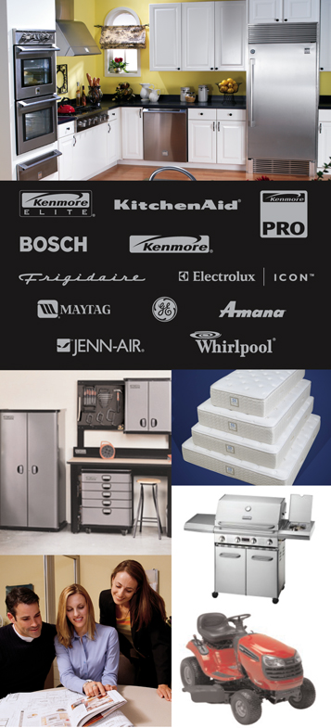


Step 1: Members simply go to sears.com and find the product(s) they are interested in and write down the product/model number(s).

Step 2: Members email the product number(s) to Company’s designated contact at Sears Appliance Select : wgill03@searshc.com for a quote. To receive this pricing a member must include their Company discount code 10064339 in the email. Members may also call 972-316-0702 for direct pricing.

Step 3: Members can then use a credit card to purchase the discounted item and it will be delivered directly to your home.

All manufacturer warranties apply with the option to purchase extended Sears Protection Agreements. Installation is not included with delivery.

